Email: dance@reveredancestudio.com
COVID Guidelines may be found on our website.

Our national award winning staff and students perform professionally on stage, in films, on TV and video and are accepted in some of today’s most prestigious dance and musical theatre programs. Our programs have been featured in USA Today, on People.com, Amy Poehler’s SMART Girls and in local and regional theatres across the US.

- Voted Best of Cincinnati’s Dance Studio 3 Consecutive years 2018-2020
- Voted Hulafrog West’s Most Loved Dance Studio – 2019 & 2020
- Located in historic Sayler Park on Revere Ave.
- Offering pre-professional and recreational training in Tap, Ballet, Jazz, Musical Theatre, Hip Hop, Lyrical, Jazz Leaps and Turns, Acro and Performance
- All of our teacher and staff require a certified background check.

Academic Term – September 14- May 29, Recital is tentatively June 5th, both at Three Rivers.
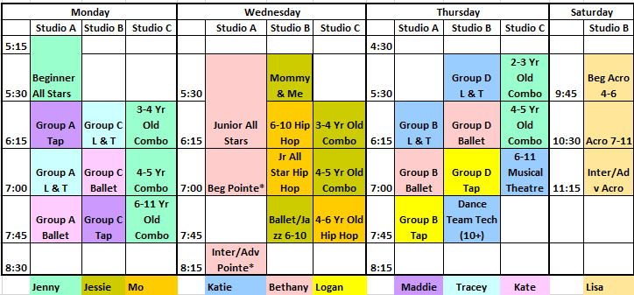

Registration: $20 + 1st month’s tuition. Tuition due 1st day of each month (there is a $15 late fee).
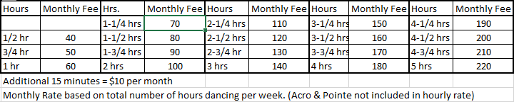

Costume Fee – $60 per class (split in 3 payments due Sept-Nov 1). 6 Minimum, 8 Max Students per Studio C classes. Group A-D Technique classes are audition only classes and only ballet technique classes are in the recital (no costumes).
Beginner All Star Team requires 1 Competition entry fee for 1 competition and Junior All Star Team requires two Competition entry fees for 2 competitions. All Star Teams registration and Team Fee is $60 and Agreement must be signed. NO AUDITION REQUIRED. Combo classes will have one dance in the recital. See our website for class attire.

REGISTRATION FORM ON BACK
Revere Dance Studio REGISTRATION (mail to: 6435 Revere Ave., Cincinnati, Oh 45233)

Family Name: ___________________________________________ Email: ________________________________________

Address: _____________________________________City: __________________________ State: _____ ZIP: _________

Phone Numbers: Home: ________________ Cell/Mobile: __________________ Work: _________________

Emergency Contact: Name: __________________________ Relationship to Student: ____________Phone: ___________________

Payment Policy: All fees are due by the 1st day of each month. There is $15 late fee.

Signature ___________________________ date ________________

Medical Release: I release from all liability and indemnity and hold harmless Revere Dance Studio, LLC, from all liability arising from or related to any injury or illness incurred by my child while participating in and/or traveling to/from Revere Dance Studio or Dance Competitions representing Revere Dance Studio. In the event of medical emergency, authorized persons will make every reasonable attempt to contact me. If I am unavailable, I authorize the emergency contact above, to give consent to physicians, dentist or hospital or any other emergency action as shall be deemed necessary or appropriate for the best interest of my child.
Signature _________________________ date ___________________

Student Information

#1 Student Name: ________________________________Gender: M/F Birthdate: ___/___/___

School: _____________________, Allergies/Medications: _________________________________

Special Notes: _______________________________________________

Class Name_____________________ Day__________ Time________ Teacher ___________

Class Name_____________________ Day__________ Time________ Teacher ___________

Class Name_____________________ Day__________ Time________ Teacher ___________

#2 Student Name: ________________________________Gender: M/F Birthdate: ___/___/___

School: _____________________ Allergies/Medications: _________________________________

Special Notes: _______________________________________________

Class Name_____________________ Day__________ Time________ Teacher ___________

Class Name_____________________ Day__________ Time________ Teacher ___________

Class Name_____________________ Day__________ Time________ Teacher ___________

#3 Student Name: ________________________________Gender: M/F Birthdate: ___/___/___

School: _____________________ Allergies/Medications: _________________________________

Special Notes: _______________________________________________

Class Name_____________________ Day__________ Time________ Teacher ___________

Class Name_____________________ Day__________ Time________ Teacher ___________

Class Name_____________________ Day__________ Time________ Teacher ___________

