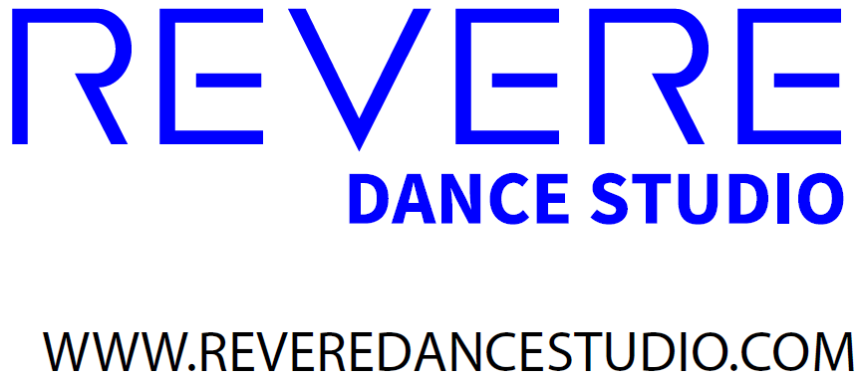
Email: dance@reveredancestudio.com
Register on line by requesting an on-line account or fill out the form below. Class sizes are limited.
TWO LOCATIONS – DOUBLE THE TALENT
6435 REVERE AVE. 5069 DELHI RD.
SAYLER PARK DELHI
Our national award winning staff and students perform professionally on stage, in films, on TV and video and are accepted in some of today’s most prestigious dance and musical theatre programs. Our programs have been featured in USA Today, on People.com, Amy Poehler’s SMART Girls and in local and regional theatres across the US.
- Voted Broadway World’s Dance Studio of the Decade
- Voted Best of Cincinnati’s Dance Studio 4 Consecutive years 2018-2020
- Voted Hulafrog West’s Most Loved Dance Studio – 2019 & 2020
- Our teachers and staff are required to have a certified background check.

- Hip Hop
- Ballet
- Jazz/Leaps & Turns
- Tap
- Acro
- Pointe
- Strength & Conditioning
- Musical Theatre

FOR THE BEGINNER (2 YEARS OLD) TO PRE-PROFESSIONAL DANCER AND PERFORMER.
See our website for level descriptions.
Revere Dance Studio REGISTRATION (mail to: 6435 Revere Ave., Cincinnati, Oh 45233) OR EMAIL US FOR AN ONLINE LOGIN TO REGISTER

Family Name: ___________________________________________ Email: ________________________________________

Address: _____________________________________City: __________________________ State: _____ ZIP: _________

Phone Numbers: Home: ________________ Cell/Mobile: __________________ Work: _________________

Emergency Contact: Name: __________________________ Relationship to Student: ____________Phone: ___________________

Payment Policy: All fees are due by the 1st day of each month. There is $15 late fee.

Signature ___________________________ date ________________

Medical Release: I release from all liability and indemnity and hold harmless Revere Dance Studio, LLC, from all liability arising from or related to any injury or illness incurred by my child while participating in and/or traveling to/from Revere Dance Studio or Dance Competitions representing Revere Dance Studio. In the event of medical emergency, authorized persons will make every reasonable attempt to contact me. If I am unavailable, I authorize the emergency contact above, to give consent to physicians, dentist or hospital or any other emergency action as shall be deemed necessary or appropriate for the best interest of my child.
Signature _________________________ date ___________________

Student Information

#1 Student Name: ________________________________Gender: M/F Birthdate: ___/___/___

School: _____________________, Allergies/Medications: _________________________________

Special Notes: _______________________________________________

Class Name_____________________ Day__________ Time________ Teacher ___________ Location _________________

Class Name_____________________ Day__________ Time________ Teacher ___________ Location _________________

Class Name_____________________ Day__________ Time________ Teacher ___________ Location _________________

